**Comparative Analysis of FTSE100 Index and UK Housing Market Performance (1992–2016)**

1. **Problem Statement**

Investors often face the critical question of where to allocate capital for the best returns — the stock market or the housing market. This project investigates how an investment in the FTSE100 index (representing the UK stock market) compares to an investment in the UK housing market over the period 1992 to 2016. By analyzing price trends, returns, and growth trajectories, this study helps clarify which asset might have been more rewarding and under what conditions.

1. **Methodology**

The project followed these structured steps:

**Step 1: Load FTSE Data**  
The historical FTSE100 index data was imported for the specified time period.

**Step 2: Prepare FTSE Data**  
Dates were converted to datetime format, set as the DataFrame index, and sorted chronologically for accurate time series analysis.

**Step 3: Extract FTSE Prices**  
The adjusted closing prices were isolated for precise return calculations.

**Step 4: Load Housing Data**  
UK housing market data for the same period was loaded.

**Step 5: Prepare Housing Data**  
Similar data cleaning and formatting were applied to ensure consistency with the FTSE data.

**Step 6: Calculate Monthly Returns**  
Monthly percentage changes were computed for both datasets to understand regular price movements.

**Step 7: Calculate Cumulative Sums**  
Cumulative returns were calculated to track how investments would grow over time if returns were reinvested.

**Step 8: Normalize Data**  
Both cumulative series were normalized to start at a base value (e.g., £100) for clear comparison.

**Step 9: Plot Data**  
A comparative line plot visualized the performance of the FTSE100 index and housing prices, helping illustrate trends and divergences.

**Step 10: Calculate Annualized Returns**  
The compounded annual growth rate (CAGR) for the FTSE100 was calculated to quantify its average yearly return.

1. **Results & Insights**

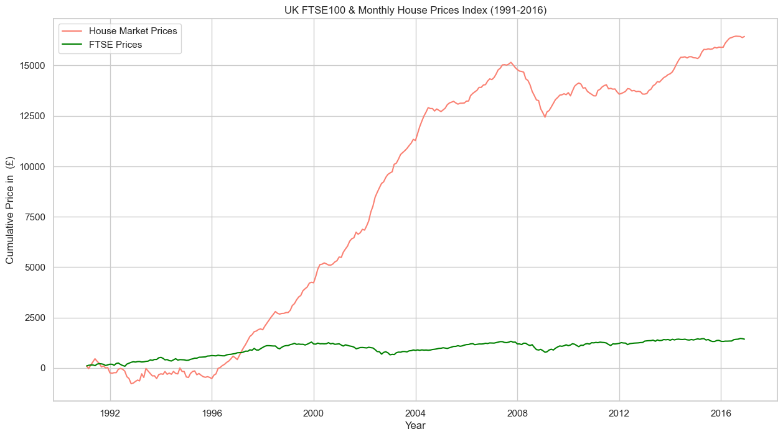

**Key Observations:**

* **Early Performance (1992–1996):**  
  The FTSE100 index showed relative stability with moderate growth. Housing prices dipped slightly during this period.
* **Housing Boom (1996–2008):**  
  A significant surge in housing prices occurred, driven by factors such as increased demand, population growth, and favorable lending conditions.
* **Post-2008 Fluctuations:**  
  The global financial crisis and its aftermath caused fluctuations in the housing market, while the FTSE100 remained relatively stable with steady, but limited, growth.
* **Strong Housing Rebound (2015–2016):**  
  Housing prices experienced another notable increase towards the end of the period.
* **Annualized Returns:**  
  The calculated annualized return shows that, depending on the chosen timeframe, the housing market generally outperformed the FTSE100 in terms of capital appreciation.

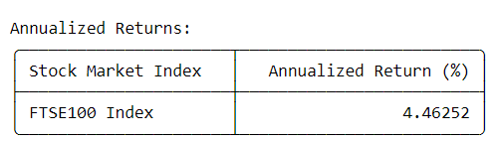

1. **Summary and Recommendations**

**Summary:**Between 1992 and 2016, the UK housing market demonstrated stronger capital growth compared to the FTSE100 index, especially during the housing boom years. However, the housing market also exhibited more pronounced price fluctuations and lower liquidity than the stock market.

**Recommendations:**

* **Align Investment with Goals:**For investors seeking capital appreciation and long-term value growth, the housing market historically offered higher returns during certain periods. However, the stock market provides better liquidity and ease of diversification.
* **Balance Risk and Liquidity:**A balanced portfolio that includes both real estate and stocks can help manage risk while capturing potential gains from each asset class.
* **Monitor Market Conditions:**Economic factors, policy changes, and demographic shifts significantly influence both asset classes. Continuous market monitoring is vital for informed investment decisions.
* **Seek Professional Advice:**Individual investment decisions should consider personal financial goals, risk tolerance, and time horizon. Consulting with a financial advisor is advisable.

1. **Data Source**

**Sources:**

* FTSE100 Index Data: Yahoo Finance or other reputable financial market data providers.
* UK Housing Market Data: UK Land Registry or Office for National Statistics (ONS).
* Access: Publicly available through financial data portals and official UK government statistical sites.